|  |  |
| --- | --- |
|  | Game Design Document |
|  |  |
|  | SWIRL  GAM 100  10/17/16 |

# Overview

Swirl is a game where the player would have to manipulate the robot to perform well enough to impress the audience in a life and death obstacle course. In this game, the primary goal of the player is to record a set of movements into the robot and ensure that during execution time, it can run smoothly and reach its objective without being destroyed.

## Storyline

The player will be in a role of a programmer whose job is to store movements into a lifeless robot. The point of the programmer is to make the audience feel that the robot is alive and is struggling and intelligently avoiding obstacles to reach its destination. Its path will be filled with dangerous hazard which can involve the robot being destroyed in several different ways.

**Story to Player**

“Your Role is to “breathe life” into this robot and ensure that it can impress the audience tomorrow! Make sure that it can escape this life and death scenario perfectly without any mistakes!

## Environment

The setting of the game will take place in a lab where “artificial intelligent” robots are put to the test whether they can truly replicate a human’s conscience. The place will be dark and filled with many hazards around the player.

General visual graphics includes using art styles that are inspired from pixel art.

## Audio Style

Music Style would include robots making gear moving sounds together with audience cheering/ jeering effects. Entire background sound would revolve around gear and hazards noise.

## General Gameplay

Reach from one point to another safely through careful planning. Record and ensure that movements in your planning has pinpoint accuracy towards reaching your destination.

Basic Controls Include:

1. Drag & Drop Features.
2. Recording & Execution of Movements.
3. Avoiding all obstacles as much as possible.

# Starting Out



Prior to getting to the first screen, Swirl will show Digipen’s logo all by itself on one screen unaltered for at least two seconds. This will act as a standalone screen independent of the game content itself.

Followed by which, a game launch screen must be shown for approximately 3 seconds and players can skip/ bypass the intro screen via any buttons on the screen.

## Game Start

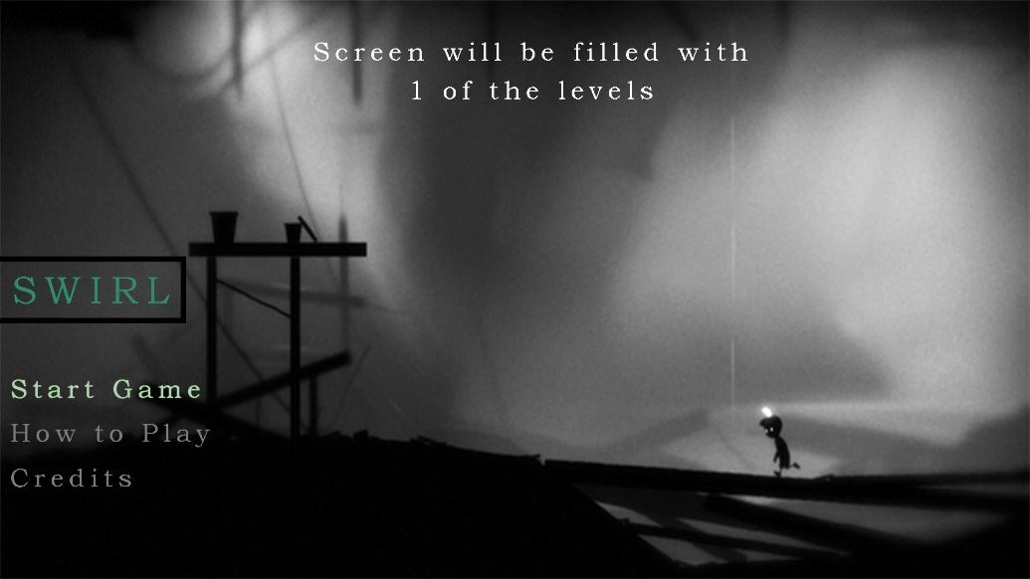

When the game loads up, players will only be able to move in between screens through up and down arrow keys. The one currently being selected will have a slight glow. To proceed to the next screen of the respective selected button, the user must press enter.

The first screen will include visuals of 1 of the levels in the game whereby it looks like the robot is trying to clear over an obstacle. Text would be shown on the left of the screen. The available screens the player would be able to proceed on includes:

1. Start Game Aka Level Selection Screen
2. How to Play Screen (Accessible from Pause Menu as well)
   1. Displays basic controls, instructions and goals of the game.
3. Credits Screen – Special Thanks and Introduction of Players